**Content Negotiation**

1. When a client specifies the media type it wants as a response to the request “Accept” header.
2. By default, ASP.NET Core Web API returns a JSON format result, and it will ignore the browser Accept header.

ASP.NET Core support below media type by default:

1. Application/json
2. Text/json
3. Text/plain

Step 1: Create a below classes:

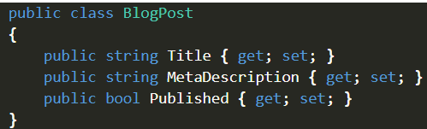

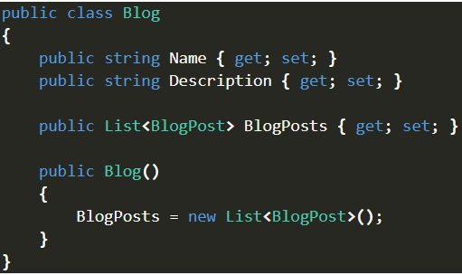

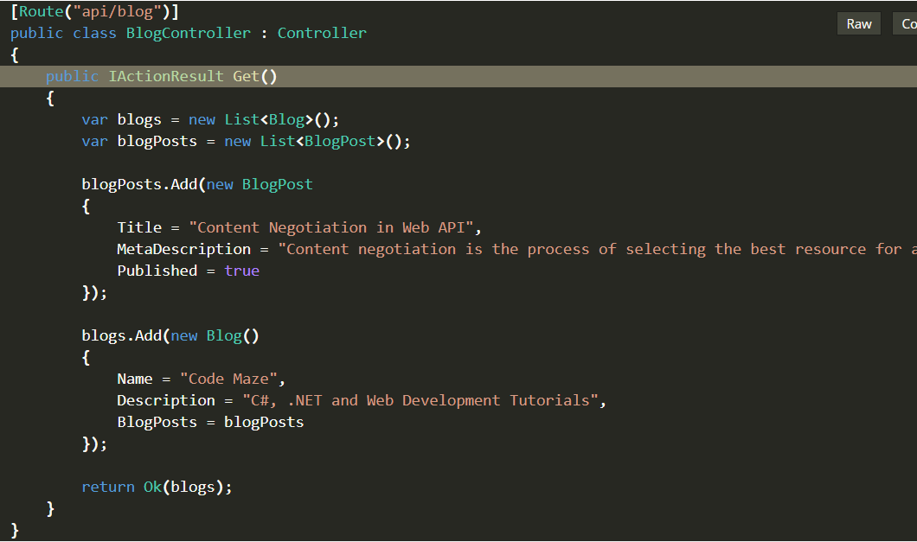

Step 2: run the URL in browser and Postman, will see the output in JSON format.

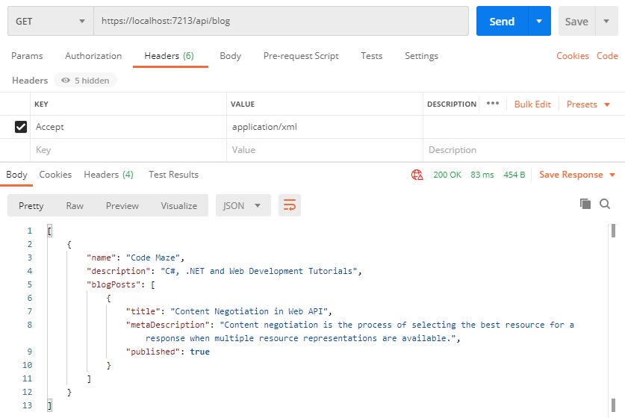

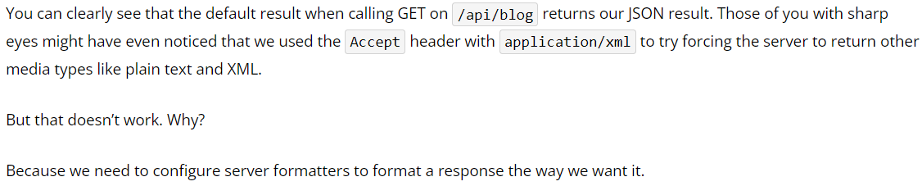

*Return XML response*

We can add the following options to enable the server to format the XML response when the client tries negotiating for it:

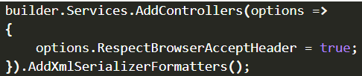

First things first, we must tell a server to respect the Accept header. After that, we just add the AddXmlSerializerFormatters() method to support XML formatters.

Now again run in browser and Postman.

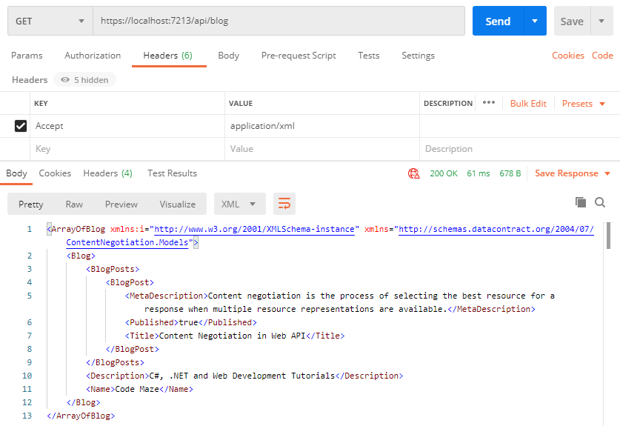

*Restrict Media Types in Content Negotiation*

1. Currently, the response will default to JSON if the media type is not recognized, but we can restrict this behaviour by adding one line to the configuration:

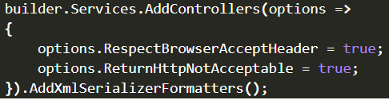

We’ve added the **ReturnHttpNotAcceptable = true** option, which tells the server that if the client tries to negotiate for the media type the server doesn’t support, it should return the **406 Not Acceptable** status code.

This will make your application more restrictive and force the API consumer to request only the types the server supports.

Now, let’s try fetching the **text/css** media type using Postman to see what happens:

